Paleontology
Day 4 Activity

DESIGN A DINOSAUR

What do you think of when someone says ‘dinosaur’? Do you think of a massive t-rex with sharp teeth and a scaly body? Maybe something that looks a little like this:
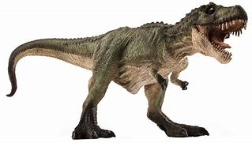
But did you know that big scary t-rex you pictured may actually look more like this:
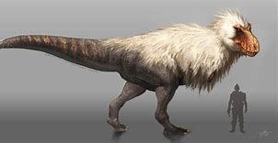
Crazy right?! Suddenly that big spooky t-rex looks a lot like an oversized chicken! As strange as this idea of a feathered dinosaur is, paleontologists have found that most dinosaurs we know of probably had feathers. They discovered this by studying fossils, an impression of a prehistoric organism preserved in petrified form or as a mold or cast in rock. Most fossils are formed when an organism is buried by water containing debris and minerals, and through the effects of wind or gravity, gets compressed into rock. This does a great job at preserving bones, which are durable and do not decay easily. However, things like skin, fur, and feathers decay much more easily and are not as well preserved as bones are. Because of this, it can be very difficult to detect feathers and fur in a fossil. Before we had the technology to detect the tiny marks left by feathers in fossils, paleontologists had to make drawings of dinosaurs without feathers, fur, or any sort of outer markings. These incomplete drawings are the scaly, bony, spiky dinosaurs that we typically see in Hollywood movies. To shed some light onto why these scaly drawings are so inaccurate, here are some modern-day animals drawn the same was that the dinosaurs in movies are.

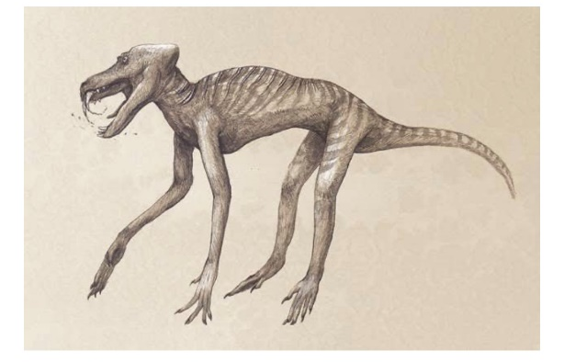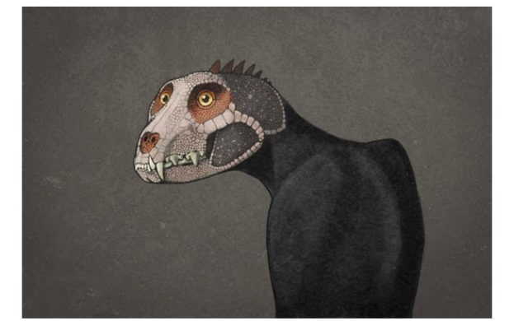
Baboon Cat
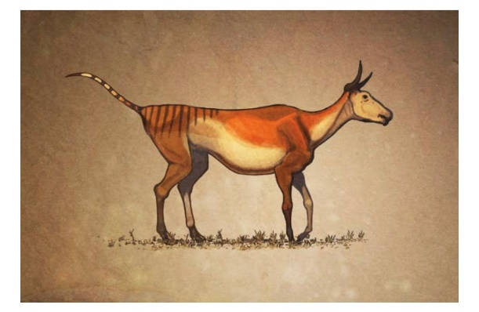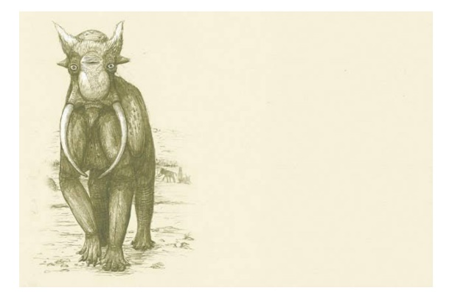
Cow Elephant
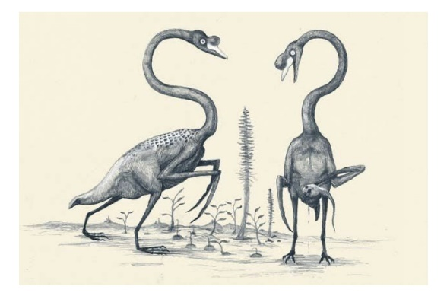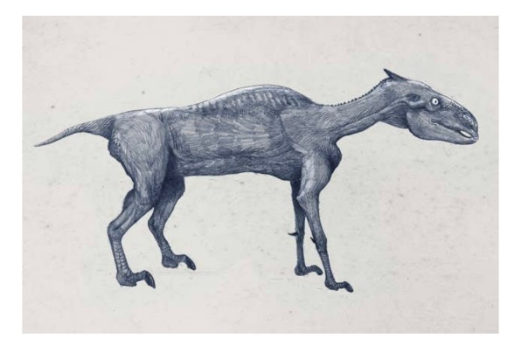
Swans Zebra
As you can see, drawing animals without considering things like feathers and fur can be very misleading, and can result in some drawings that are much creepier than the real animal! In order to make sure we have the most accurate drawings of dinosaurs, paleontologists spend their lives carefully studying fossils to find out what dinosaurs really looked like. The more we study fossils of dinosaurs, the more accurate of a picture we can create of how they actually looked. So, next time you watch Jurassic Park with your family, remember that big scary t-rex probably looked more like a big fluffy turkey!

Now that you have learned about how dinosaurs probably had feathers instead of scales, its your turn to make a dinosaur!

Materials Needed:
Materials from Supply Box | Materials from Home
- Dinosaur skeleton page  - Small bag of feathers, sequins, googly eyes, yarn, etc.  - Crayons | - Markers and/or colored pencils (optional)  - Kid’s craft glue

Directions:
- Choose your dinosaur skeleton page
- Think about what you want your dinosaur to look like. Will it have feathers or scales? What color will your dinosaur be? Does this species of dinosaur have a name? What did it eat?
- Thinking about layers, it is important to color with crayons and/or markers before you use glue to attach any extra bling.
- Let your creation dry, then share your dino zoo with your family and friends.

Let’s Take it Further:
- Write out a brief blurb about your dinosaur, as if you were making a flashcard for your fellow student.
- What evidence can you use to design your dinosaur as accurately as possible?

Additional Resources to Check Out:
https://www.sciencenewsforstudents.org/article/feathers-what-every-dino-wore
https://www.amnh.org/learn-teach/curriculum-collections/dinosaurs-activities-and-lesson-plans/functions-of-feathers
https://podcasts.google.com/feed/aHR0cDovL3Jzcy5hcnQxOS5jb20vZ2V0dGluZy1jdXJpb3VzLXdpdGgtam9uYXRoYW4tdmFuLW5lc3M/episode/MTkzN2M0MDctYTUyYy00ZDNkLWIzNjktYWJjODAwMDhhMzhi?hl=en&ved=2ahUKEwiJseOgztfqAhVYlXIEHbAvB-kQieUEegQIBRAS&ep=6
https://www.youtube.com/watch?v=w6qUcVxIQLg
http://www.oum.ox.ac.uk/thezone/fossils/intro/proof.htm

