Rising 2-7th Grade Summer Camp Policies and Procedures
Our counselors review our camp expectations with all campers at the beginning of each camp week. This is to ensure a safe, positive, and happy camp environment. It is expected that parents/guardians will review these policies and procedures before the beginning of the respective camp week.
FAQ
What time does camp begin and end?
Full Day: 9AM – 5PM
What time should I drop off and pick up my camper?
Drop-off is between 8:45-9:00AM. Programming begins at 9:00AM.
Pick-up will begin at 4:45PM and be completed no later than 5:15PM.
*After 5:15PM, parents will be charged $10.00 for each additional 5-minute period after 5:15PM to be billed at the end of the camp session.
*Early drop off and late pick up are available at an additional fee. See camp add-ons in the EXTRA section below.
Who the camp instructors and what are their qualifications?
The lead camp instructors for each age group are highly qualified expert STEM educators. All camp staff have experience with STEM education, camp and classroom management, and are First Aid and CPR certified. Campers will also receive programming support and expertise from community partners, STEM experts, and AMOS interns and volunteers.
Where should I drop off and pick up my child?
Drop-off and pick-up most days will be in the UNC Asheville. Your child will have one AMOS day. On this assigned day drop-off and pick-up will be in Downtown Asheville.
How does AMOS guarantee a safe learning experience?
AMOS practices positive and proactive education and camp management tactics. We emphasize positive hands-on activities to keep students engaged and focused in a fun environment. AMOS camp staff also enforce a strict no-tolerance policy when it comes to bullying and any behaviors deemed dangerous to a camper’s peers, to themselves, or to staff. In the case of negative behaviors, AMOS enforces a 3-strike policy detailed in the Expected Behavior section below.
How do I add an authorized person to my campers approved pick up list?
To add an authorized person to your campers approved pick up list, using the same email from registration please email edu@ashevillescience.org or provide in person your name, your child's name, and the name and phone number of the person you would like to add.

What should my child bring?
Lunch
Snacks
Water Bottle
Sunblock/Sun Exposure Prevention
Hat
Sweatshirt or jacket
Camp store spending money

What should my child NOT bring?

Cell Phones
Computers/Tablets
Inappropriate/Distracting Items
SNACK/LUNCH/WATER
Each day is full of fun activities and new experiments. Lunch is an important time to relax and re-energize during the middle of the day. Be sure to send your child to camp with a lunch and a morning snack each day that does not require refrigeration! Campers will have two designated snack times daily. We ask for parents to pack the morning snack and we will provide the afternoon snack.
Due to allergies, please refrain from packing food items that contain peanuts. Water is also very important; please pack a water bottle.
STUDENT DRESS CODE
Students must wear closed toed shoes always, except for pool time. We recommend dressing for an active summer day with layers for times that we are inside the classroom.
Safety and practicality is the foundation for the student dress code policy. Depending on the activities for the day, appropriate clothing may change. If there are special needs for dress this will be communicated by camp counselors in advance to students and parents.
DROP OFF/PICK UP
To ensure the safety of campers, staff, and the public please review the drop off and pick up procedures carefully. In general, we hope this process to be fast and efficient to ensure that your camper has an optimal amount of time for the day’s activities.
2-4th Grade Campers will be at both AMOS and UNCA during their camp experience:
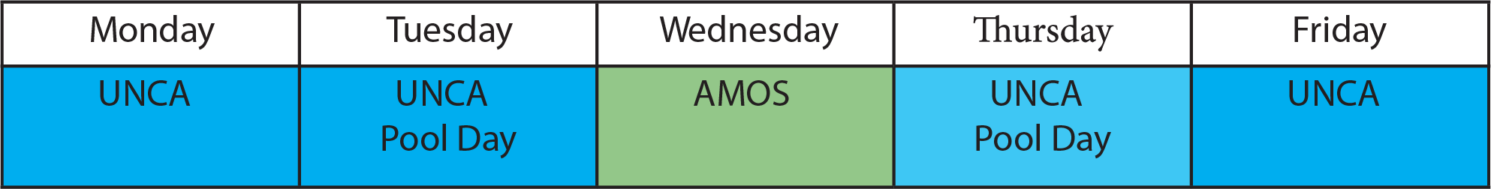
5-7th Grade Campers will be at both AMOS and UNCA during their camp experience:
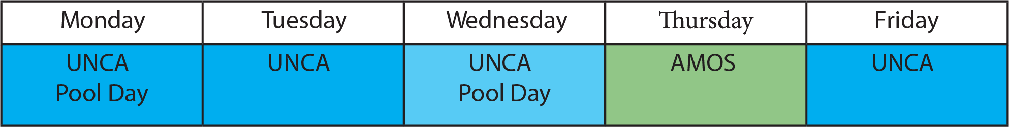
For a camper to be picked up, a pre-authorized person (each camper has this filled-out upon registration) must present a valid picture ID and sign the camper out. To change, add, or restrict pre-authorized pick-up contacts, please email edu@ashevillescience.org.
WHEN:
Drop off: 8:45AM- 9:00AM
Pick Up: Full-Day: 4:45-5:00PM
If necessary, contact your camper’s counselor to locate the group if dropping of late or picking up early.
After 5:15PM, parents will be charged $10.00 for each additional 5-minute period after 5:15PM to be billed at the end of the camp session.

WHERE:
UNCA Drop Off/Pick Up
1 University Heights
Asheville, NC 28804
Parking Lot P12
Classroom Building: Zaiger Hall

For UNCA drop-off and pick-up we have arranged a covered vehicle line pick up for convenience and timing. Please refer to the traffic map below. If a parent needs to park you may do so in Parking Lot P10.
When arriving on campus proceed to Parking Lot P 12. Enter the covered parking deck off Campus Dr. Parents are encouraged to stay in their vehicles and will be met by a camp counselor to check in and out their camper in the vehicle line. Exit the parking garage on the opposite side. Pick up will follow the same route.
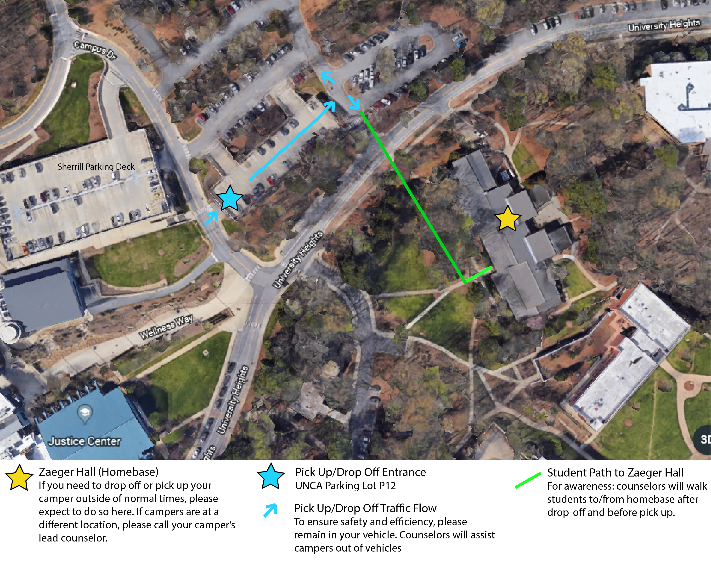

AMOS Drop Off/Pick Up @ Central United Methodist Church
27 Church St
Asheville, NC 28801
For AMOS drop-off and pick-up we have arranged a vehicle line pick up for convenience and timing. Please refer to the traffic map below. If a parent needs to park you may do so in a city lot, garage, or street parking.
When arriving downtown, turn right onto Church St off of Patton Ave. Continue down Church St to Central United Methodist Church (on your right). Parents are encouraged to stay in their vehicles and will be met by a camp counselor to check in and out their camper in the vehicle line. Pick up will follow the same route.

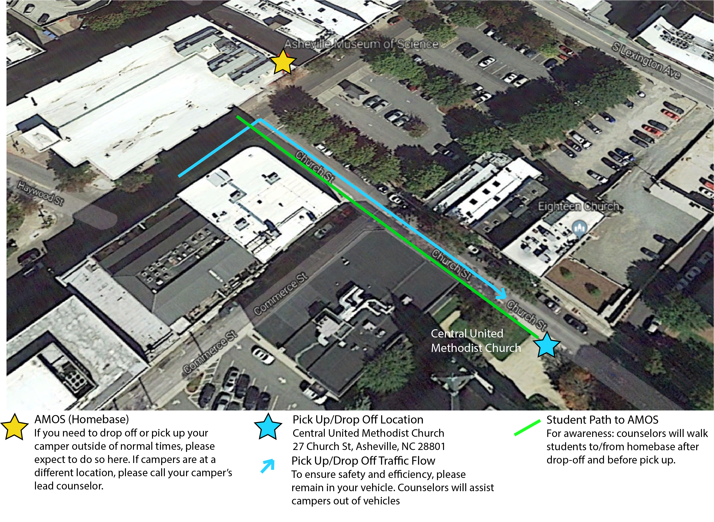
Pick Up/Drop Off Resources:
For the UNCA Map visit: https://maps.unca.edu/
For Downtown Asheville parking information visit: https://www.ashevillenc.gov/departments/parking/find_parking.htm

EXPECTED BEHAVIOR
AMOS Camps emphasizes a safe, fun, and healthy camp environment that fosters learning and friendship. Appropriate camp behavior is essential to a great overall experience for everyone involved. It is imperative that every camper feels included, safe, and part of our camp community. For behaviors that distract counselors and/or students from daily activities the following protocol will be followed:
Strike One: Warning: Student will be pulled aside and given a constructive warning about why their behavior is inappropriate. If necessary multiple students may be brought together for a conversation about a behavior. Warning will be documented by counselors.
Strike Two: Warning and Parent Contact: If distracting behaviors continue, student(s) will be given a second warning paired with a phone call home. This warning and call will be documented by counselors.
Strike Three: Parent Conference: After a second warning, if the behaviors continue, the parent will be called into camp to discuss further necessary actions. These may include but are not limited to daily check-ins, limiting activity time, early pick-up, or dismissal from camp. The conference will be documented by counselors.
AMOS Camps reserves the absolute right to dismiss a camper without refund for any behavior deemed by AMOS Counselors that:
(1) threatens or endangers the welfare and/or the safety of any camper, instructor, or any other person involved with the camp
(2) is disruptive to the overall camp environment and/or interferes with the positive experience of campers and staff
(3) takes form of bullying* of other campers or any disrespectful behavior toward camp authority
*Bullying: While there will be many various challenges that campers will have to navigate this summer (with help from their counselors), we recognize that bullying continues to be a primary concern. Whether in school, on teams or even at camp, children will engage in behavior at times that causes others to feel excluded, uncomfortable, and even threatened. We want all families to understand that at camp, bullying (whether coming in the form of emotional or physical actions against others) is not acceptable. We prescribe to a “zero tolerance” policy that requires us to address bullying concerns seriously and swiftly, and to act when confirmed bullying is taking place. At times, the result of bullying at camp will be thoughtful mediation and problem-solving with an adult (counselor, Camper Care staff members, supervisor, etc.) with careful follow-up with the parent and camper. At other times, families will be contacted to discuss a more serious issue. If the situation is grave and has had a major impact on another member of the community, campers may be dismissed. If you are aware of bullying at camp, suspect a situation that could arise, or if you have specific concerns, we strongly encourage you to raise these issues with our camp staff. We are committed to maintaining a healthy and positive community and will do our very best to protect every child in our care.

CONTACT and COMMUNICATION
Contacting a Counselor or Camp Coordinator:
You may contact our camp staff with the below information or our Camp Coordinator during the camp week. If appropriate, a note may also be sent with a camper for a counselor.
Camp Coordinator
Dani Hammond: 828-484-1305, edu@ashevillescience.org
Onsite Lead 2-4th Grade Counselor Contact
Scott Kessler: TBD-contact camp coordinator
Onsite Lead 5-7th Grade Counselor Contact
Hannah Hunt: 540-234-2096
AMOS: 828-254-7162

INCLEMENT WEATHER PROCEDURES
In the case of inclement weather (thunder, lightning, etc.), counselors will monitor weather closely to ensure the safety of all campers.
In the case of inclement weather during student pick up or drop off, please refer to the following procedure:
- Campers will stay in their home-base location
- Counselors will use the Remind app to send the parents of campers a message indicating that there is inclement weather and that they are to park and drop off/pick up their camper at home-base
- Have your phones ready and available for phone calls and messages
Inclement Weather Parent Parking
AMOS-it is recommended that parents utilize street parking or the Rankin St parking garage.
UNCA-parents are welcome to park in any non-resident lots, including P10/11 (adjacent to normal pick up and drop off).

ELECTRONIC DEVICES
Campers are not permitted to use cell phones, personal computers, or any other electronic devices that connect to the internet while at camp except for camp owned computers used for camp purposes.
“While at camp” pertains to all times that a camper is on location at camp. If you would like to get in touch with your child during the camp day, please contact our onsite camp counselors.

PERSONAL PROPERTY and APPROPRIATE ITEMS
AMOS is not responsible or liable for any personal items/equipment that is lost, stolen, left behind, or broken.
If a personal item becomes a disruption to learning, counselors hold the right to confiscate said item until the end of the day and item will be returned to an adult during pick-up.
Campers are prohibited to bring inappropriate items to camp such as but not limited to weapons, drugs, R-rated materials, etc.
“LOST AND FOUND”
AMOS is not responsible or liable for any personal items/equipment that is left behind at camp. All “Lost and Found” items/equipment will be held at camp until the last day of camp. All “Lost and Found” items/equipment that are not picked up at camp by the last day of camp will be discarded or donated.

ILLNESS AND INJURY/MEDICATION
Our number one objective is to do everything possible to ensure the well-being and safety of each camper. Camp is designed to be a fun and exciting learning environment however small injuries may not be avoidable.
It is expected the campers will immediately report any injury to a counselor that may not be observed in which case first aid may be given and injury will be evaluated. All injuries will be documented by counselors. No medication may be administrated by counselors unless previous permission has been granted by a parent or guardian.
In the case of an emergency, as deemed by camp counselors or upon request by parent or guardian emergency services may be called.
It is expected that parents will notify AMOS before camp of any pre-existing conditions a camper has such as a recent injury or illness. However, all expenses are the responsibility of the parent or guardian.

If a camper will be taking medication during camp hours (9:00AM-5:00PM):
- Package medication in a plastic bag/container with instructions on use, time of consumption, method of consumption, and camper’s name
- During morning drop-off, sign in the medication with the Lead Counselor to hold onto until proper time of consumption.

NUT-AWARE CAMP
For the safety of our campers, we are a Nut-Aware camp. Please do not send any nut products to camp with your child. While we are a “Nut-Aware” camp, we cannot guarantee a nut-free environment.

