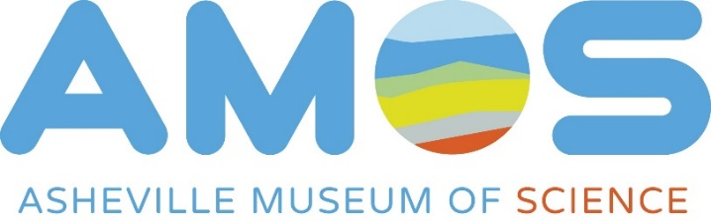
Summer Science Camp Confidential Scholarship Application (2018)
The 2018 Summer Science Camp scholarship fund is
provided by a Duke Energy Foundation grant.

Scholarship opportunities are limited and recipients are selected based on a needs basis. The first round of scholarship applications is due by midnight on April 16th, with scholarships being awarded by April 24th. If all scholarship positions are not filled by April 24th, there is potential for a second round to follow. Information included on this application will be kept confidential, to be viewed only by the AMOS scholarship selection committee.
Camper Information
Child’s Name: __________________________ Rising Grade Level: _______________________
Current School Attending: _______________________________________________________________

Family’s Information
Address: _______________________ City: _________________ Zip Code: ______________

Parent/Legal Guardian Name: ___________________________ Phone #: __________________________
E-mail: ____________________________________________________
Employer: _________________________________________________

Parent Name # 2 (optional): _________________________ Phone #: __________________________
E-mail: ____________________________________________________
Employer: _________________________________________________

Number of People in Household: ____________

Eligibility Criteria
Total Household Work Income: $ _______________ Circle One: Annual/Monthly/Weekly
Explain your reasons for applying for a scholarship, with emphasis on your current hardship, financial situation, and needs of your child:
____________________________________________________________________________________________________________________________________________________________________________________________________________________________________________________________________________________________________________________________________________________
____________________________________________________________________________________________________________________________________________________________________________________________________________________________________________________________________________________________________________________________________________________

Camp Preferences
Please rank your top three choices from our 2018 summer camp options
- ____________________________________________________
- ____________________________________________________
- ____________________________________________________
Half-Day Camps: Rising K-2nd Grade Students
Young Inventors: June 18-22, 2018
Young Inventors: July 9-13, 2018
STEM Camp: July 25-29, 2018
STEM Camp: July 16-20, 2018
Full-Day Camps: Rising 2-7th Grade Students
Engineering Exploration: June 18-22, 2018
Space Investigators: June 25-29, 2018
Earth Ambassadors: July 9-13, 2018
Makers Unite: July 16-20, 2018

