Summer Camp Policies and Procedures
Our counselors review our camp expectations with all campers at the beginning of each camp week. This is to ensure a safe, positive, and happy camp environment. It is expected that parents/guardians will review these policies and procedures before the beginning of the respective camp week.
SNACK/LUNCH/WATER
Campers will have two designated snack times daily. We ask for parents to pack the morning snack and we will provide the afternoon snack. Be sure to send your child to camp each day with a lunch and a water bottle.
STUDENT DRESS CODE
Students must wear closed toed shoes always, except for pool time. We recommend dressing for an active summer day with layers for times that we are inside the classroom.
Safety and practicality is the foundation for the student dress code policy. Depending on the activities for the day, appropriate clothing may change. If there are special needs for dress this will be communicated by camp counselors in advance to students and parents.
DROP OFF/PICK UP
To ensure the safety of campers, staff, and the public please review the drop off and pick up procedures carefully. In general, we hope this process to be fast and efficient to ensure that your camper has an optimal amount of time for the day’s activities.
It is not recommended that parents leave their vehicles during the drop-off/pick-up process. This inhibits drop-off efficiency and causes traffic flow blockages. If a parent needs to speak with a camp counselor or the camp director, please see the contact and communication procedure below.
For the UNCA Map visit: https://maps.unca.edu/
For a camper to be picked up, a pre-authorized person (each camper has this filled-out upon registration) must present a valid picture ID and sign the camper out.
Drop Off:
When: It is expected that all campers will be dropped off between 8:45AM and 9:00AM each morning. After 9:00AM, parents will need to park in a visitor parking lot (see UNCA Map) and walk child into the appropriate building. If necessary, contact your child’s counselor to locate the group (see the contact and communication procedure below).
Where: University of North Carolina Asheville-Parking Lot P26. See diagram below for proper traffic flow.
Pick Up:
When: It is expected that all campers will be picked up between 4:45PM and 5:00PM each afternoon. After 5:00PM, parents will be charged $10.00 for each additional 5-minute period after 5:15PM to be billed at the end of the camp session.
Where: University of North Carolina Asheville-Parking Lot P26. See diagram below for proper traffic flow.

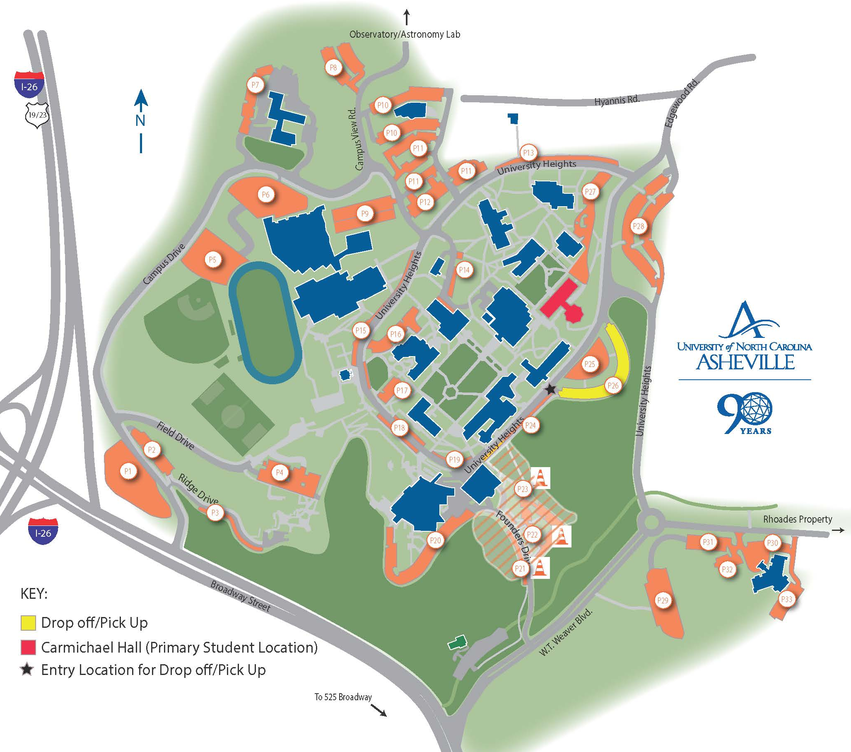

EXPECTED BEHAVIOR
AMOS Camps emphasizes a safe, fun, and healthy camp environment that fosters learning and friendship. Appropriate camp behavior is essential to a great overall experience for everyone involved. It is imperative that every camper feels included, safe, and part of our camp community. For behaviors that distract counselors and/or students from daily activities the following protocol will be followed:
Strike One: Warning: Student will be pulled aside and given a constructive warning about why their behavior is inappropriate. If necessary multiple students may be brought together for a conversation about a behavior. Warning will be documented by counselors.
Strike Two: Warning and Parent Contact: If distracting behaviors continue, student(s) will be given a second warning paired with a phone call home. This warning and call will be documented by counselors.
Strike Three: Parent Conference: After a second warning, if the behaviors continue, the parent will be called into camp to discuss further necessary actions. These may include but are not limited to: daily check-ins, limiting activity time, early pick-up, or dismissal from camp. The conference will be documented by counselors.
AMOS Camps reserves the absolute right to dismiss a camper without refund for any behavior deemed by AMOS Counselors that:
(1) threatens or endangers the welfare and/or the safety of any camper, instructor, or any other person involved with the camp
(2) is disruptive to the overall camp environment and/or interferes with the positive experience of campers and staff
(3) takes form of bullying* of other campers or any disrespectful behavior toward camp authority
*Bullying: While there will be many various challenges that campers will have to navigate this summer (with help from their counselors), we recognize that bullying continues to be a primary concern that children must deal with. Whether in school, on teams or even at camp, children will engage in behavior at times that causes others to feel excluded, uncomfortable, and even threatened. We want all families to understand that at camp, bullying (whether coming in the form of emotional or physical actions against others) is not acceptable. We prescribe to a “zero tolerance” policy that requires us to address bullying concerns seriously and swiftly, and to act when confirmed bullying is taking place. At times, the result of bullying at camp will be thoughtful mediation and problem-solving with an adult (counselor, Camper Care staff members, supervisor, etc.) with careful follow-up. At other times, families will be contacted to discuss a more serious issue. If the situation is grave and has had a major impact on another member of the community, campers may be dismissed. If you are aware of bullying at camp, suspect a situation that could arise that might be “following” your child from home, or if you have specific concerns, we strongly encourage you to raise these issues with our camp staff. We are committed to maintaining a healthy and positive community and will do our very best to protect every child in our care.

CONTACT and COMMUNICATION
Contacting a Counselor or Camp Director:
You may contact our Counselors with the below information or our Executive Director, Anna Priest at (828) 254-7162 during the camp week. If appropriate, a note may also be sent with a camper for a counselor.
Onsite 2-4th Grade Counselor Contact
Melissa Prosnak: 828-222-0838
Onsite 5-7th Grade Counselor Contact
Dani Pollard: 828-365-8419
Camper Contacting Parent:
If your child would like to contact you during the camp day, he/she may contact you through the camp counselor, given that the appropriate contact information has been provided.

ELECTRONIC DEVICES
Campers are not permitted to use cell phones, personal computers, or any other electronic devices that connect to the internet while at camp except for camp owned computers used for camp purposes.
“While at camp” pertains to all times that a camper is on location at camp. If you would like to get in touch with your child during the camp day, please contact our onsite camp counselors.

PERSONAL PROPERTY and APPROPRIATE ITEMS
Campers may bring personal items/equipment to camp, but AMOS Camps is not responsible or liable for any personal items/equipment that is lost, stolen, left behind, or broken.
If a personal item becomes a disruption to learning, counselors hold the right to confiscate said item until the end of the day and item will be returned to an adult during pick-up.
It is expected that campers will not bring inappropriate items (weapons, drugs, R-rated materials, etc.). Such is subjectable to disciplinary action.

“LOST AND FOUND”
AMOS Camps is not responsible or liable for any personal items/equipment that is left behind at camp. All “Lost and Found” items/equipment will be held at camp until the last day of camp. All “Lost and Found” items/equipment that are not picked up at camp by the last day of camp will be discarded or donated.

ILLNESS AND INJURY/MEDICATION
It is expected that parents will notify AMOS before camp of any pre-existing conditions a camper has. Pre-existing conditions include illnesses or injuries that have occurred recent to the beginning of camp week.
It is expected the campers will immediately report any injury to a counselor in which case first aid may be given and injury will be evaluated. All injuries will be documented by counselors. No medication may be administrated by counselors unless previous permission has been granted by a parent or guardian.
In the case of an emergency, as deemed by camp counselors or upon request by parent or guardian emergency services may be called. However, all expenses are the responsibility of the parent or guardian.
If a camper will be taking medication during camp hours (9:00AM-5:00PM):
- Package medication in a plastic bag/container with instructions on use, time of consumption, method of consumption, and camper’s name
- During morning drop-off, hand the medication to the Camp Director or counselor to hold onto until proper time of consumption

NUT-AWARE CAMP
For the safety of our campers, we are a Nut-Aware camp. Please do not send any nut products to camp with your child. While we are a “Nut-Aware” camp, we cannot guarantee a nut-free environment.

